Introduction to Foundry & AIP for Enterprise Organizations

Course Overview
You’ll learn the” what & why“ of Foundry and AIP. You’ll learn about its key components and unique value propositions. After this course, you’ll be well-positioned to start hands-on training!

Course Introduction - Why do Foundry and AIP exist ?

Contextualizing the problem space
The Initial Landscape
Foundry and AIP exist to provide data-driven operations and decision-making software. Their mission is to enable organizations to harness the full potential of their data. The software is constantly enriched and improved by applying learnings from the field. By creating a more integrated and dynamic data management ecosystem, the platform empowers everyone to make more informed, effective decisions.

Concretely, what does this mean in the context of a company?
Organizations today are on a transformative journey. They are navigating through vast amounts of data dispersed across various systems, attempting to derive value and efficiency from their exploitation. This exploitation involves several stages, from data collection to integration, transformation, and reporting.

The Traditional Data Flow
The traditional approach to managing data can be likened to an assembly line – a linear flow where data moves from producers to consumers.

This flow typically involves:
- Integration: Combining data from different sources.
- Transformation: Converting data into a usable format.
- Reporting: Generating insights and reports for decision-making.

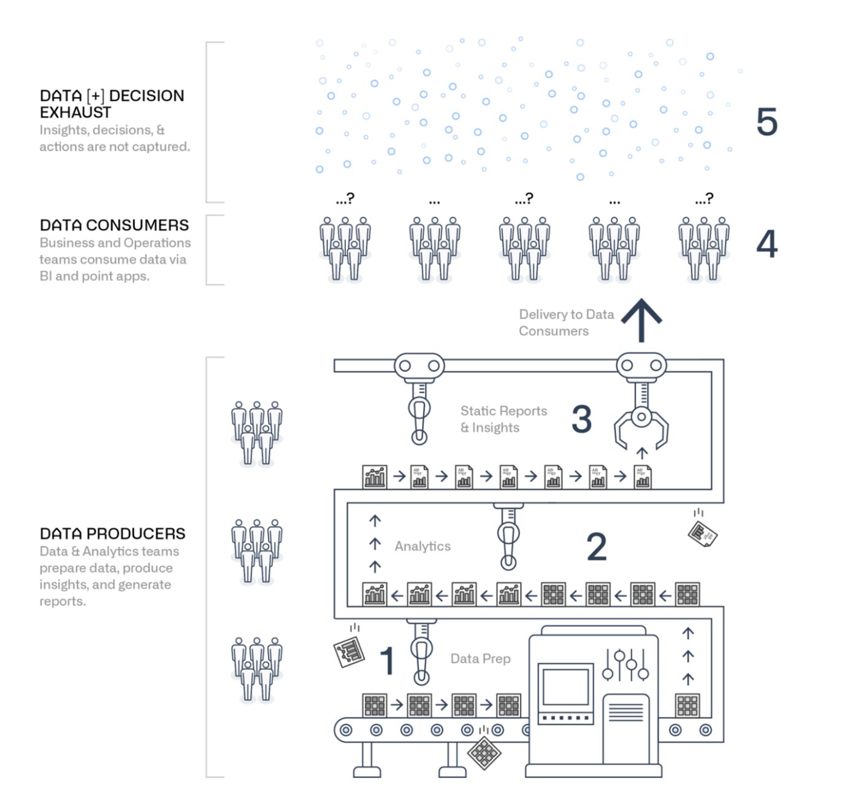

Challenges of the Linear Flow
While the assembly line model is effective in certain aspects, it leaves several opportunities untapped:

- Capturing Learnings: The linear flow often fails to capture the valuable learnings that occur during data processing.
- Materializing Decisions: Decisions made based on data insights do not always effectively materialize.
- Feedback Loop: There is often a disconnect between the front-line personnel and the back-office data analytics team. This lack of a feedback loop can hinder continuous improvement and innovation.

The Need for Evolution
Most organizations recognize the limitations of a linear data flow model and feel the need to evolve beyond it. They aim to create a more dynamic system that facilitates better communication, faster decision-making, and a robust feedback mechanism.

Approaching this with Foundry and AIP

Proposed Approach: Operational Connectivity
Foundry and AIP are designed in a way for you to iterate on production data and build tools quickly for your users while ensuring strict data governance with integrated, intuitive tooling. They facilitate real-time collaboration and enable the integration of AI-powered workflows into business processes.

Operationalizing Data
Foundry and AIP integrate your operations with data and analytics, making data accessible and actionable for everyone, to yield true value from this deep connection.

Empowering All Users
Foundry and AIP empower users across all roles, not just data scientists and engineers, by making data a part of everyday tasks. This democratization ensures that data-driven insights are available to everyone, enhancing collaboration and efficiency across various teams and departments.

Interoperability with Data Sources
Organizations often have data dispersed across multiple systems. Foundry and AIP connect these diverse data sources, breaking down silos and promoting seamless data flow. This interoperability ensures that data producers and consumers can collaborate effectively, leveraging the full potential of available data.

Enforcing a Common Language
One of the key challenges in data management is understanding and integrating data from various sources. Foundry and AIP address this by enforcing a common language early in the process. By using an ontology, Foundry standardizes data interpretation, making it easier for teams to understand and utilize data without extensive mapping and logic deciphering.

Central and Secure Hub
Foundry serves as a central, secure hub for all your data needs. It supports two-way interactions, allowing data to be both fed into and accessed from the system. Additionally, Foundry provides granular control over data permissions, ensuring secure and compliant data management tailored to organizational policies.

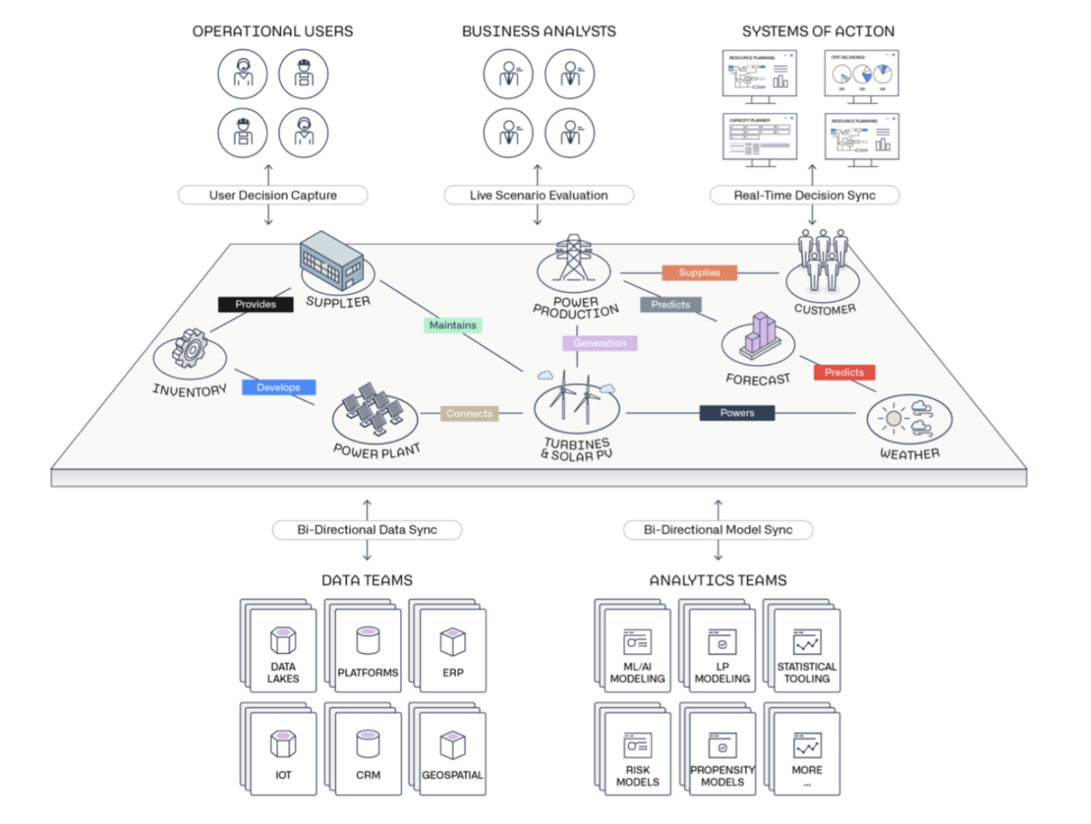

A high-level view of the platform

Diving into the Palantir platform
A set of capabilities, functionality and tooling
- Foundry is Palantir's data operations platform, with the Ontology at its heart - it allows for enterprises to execute faster with universal logic representing the objects, actions, and processes of their business.
- Palantir AIP connects generative AI to operations.
- Apollo is Palantir's mission control for autonomous software deployment.
Together these make up the Palantir platform encompassing eight core capabilities an enterprise needs to bring Data and AI to production at scale in a safe and secure way.

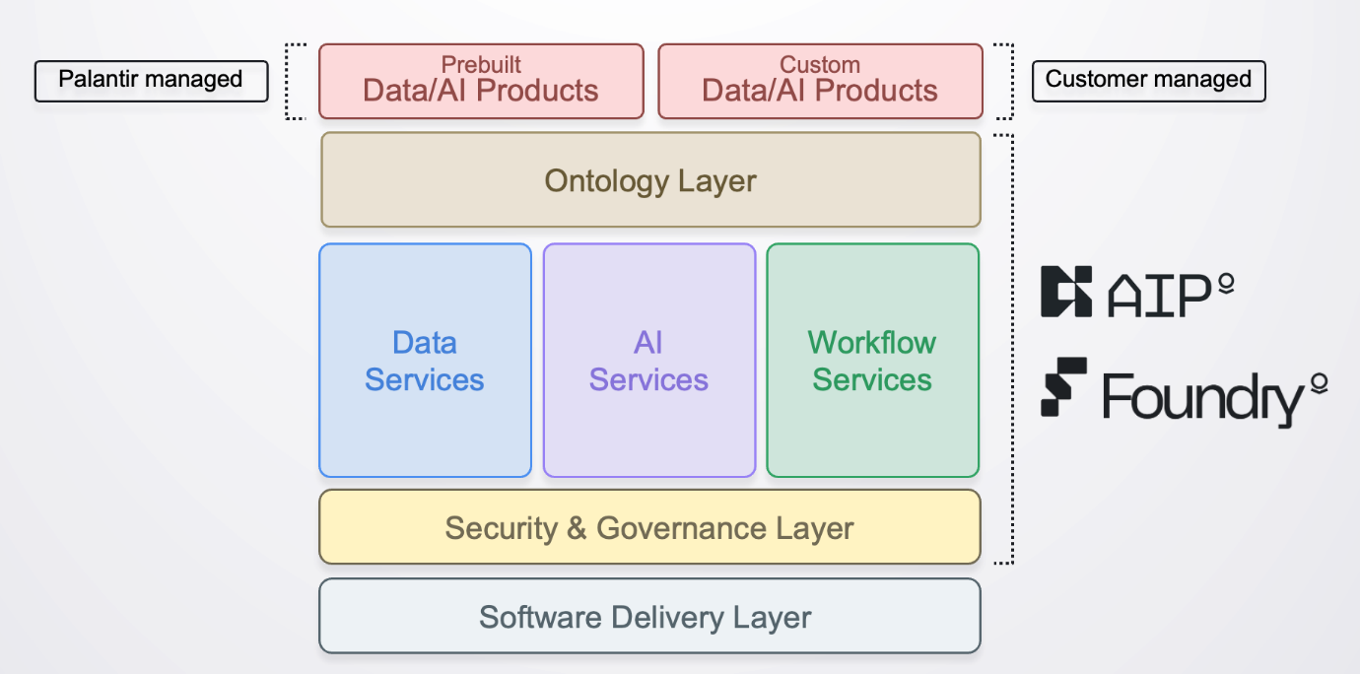

Section 1: The Centerpiece - The Ontology

Overview
In this section, we will delve into the core component of Foundry: the Ontology. Understanding the Ontology is essential as it forms the backbone of how Foundry operationalizes data across an organization.

What is the Ontology?
The Ontology is a semantic layer that models a company’s data to ensure it is usable and understandable by all business users. It bridges the gap between complex data from various source systems and the business logic, translating it into familiar business terms. This makes the data accessible and actionable for everyone in the organization, providing a single source of truth for data-driven operations and decision-making.

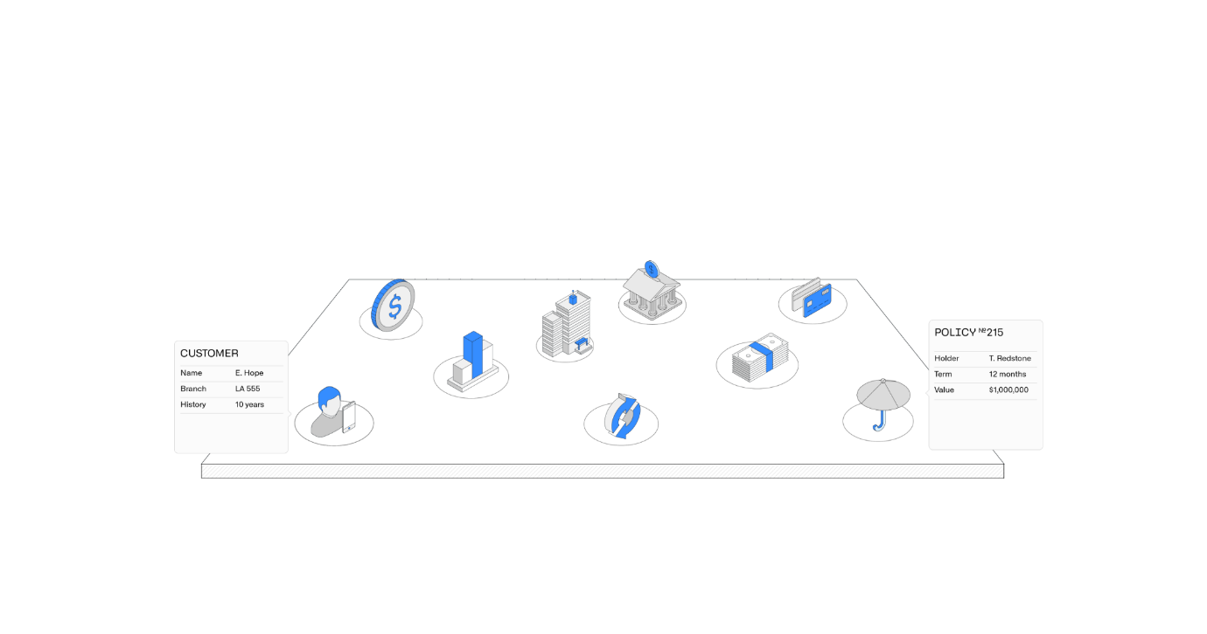

Components of the Ontology
1. Objects in the Ontology
The Ontology is composed of objects, which represent unique entities such as banks, cashflows, people, clients, contracts, or policies. These objects serve as the building blocks of the Ontology.

2. Links in the Ontology
Objects within the Ontology can be linked together to reflect business activities. For example, a signed contract (one object) would be linked to the client it is signed with (another object), which is then associated with cashflows (yet another object). These links create a comprehensive and interconnected view of the business.

3. Curated Access
Objects and Links within the Ontology can be configured to granularly provide access rights to different users, depending on their role and rights with regards to data access and modification.

The Goal of the Ontology
The primary goal of the Ontology is to reflect the business through data in a unified, clean, and structured way. By providing a clear and consistent representation of business entities and their relationships, the Ontology ensures that data is not only accurate but also meaningful and actionable for all users.

Recap
To recap: Ontology = Data, Models, and Business Logic
The Ontology serves as the semantic layer that integrates data, models, and business logic, making the information usable and understandable for everyone in the organization.
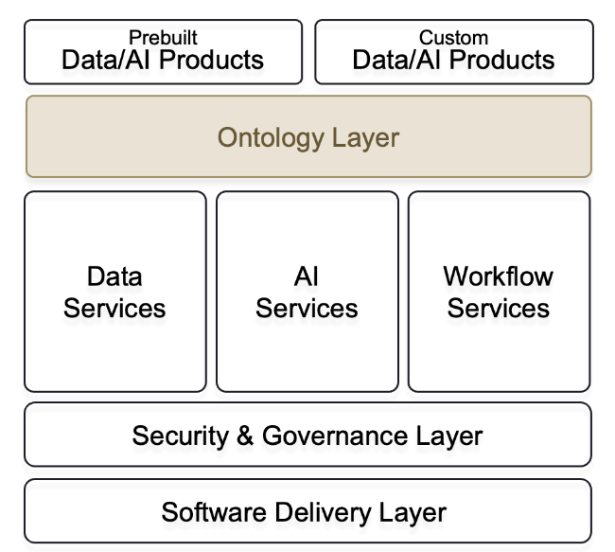

Section 2: Data Integration

Overview
In this section, we will explore how Foundry integrates data from across the company to build a cohesive and comprehensive data ecosystem. Effective data integration is crucial for the Ontology to function seamlessly and provide meaningful insights.

What is Data Integration?
Data integration in Foundry and AIP involves bringing together data from various sources within the organization. This integration ensures that all relevant data is accessible and usable within the Ontology, providing a single source of truth for data-driven decision-making.

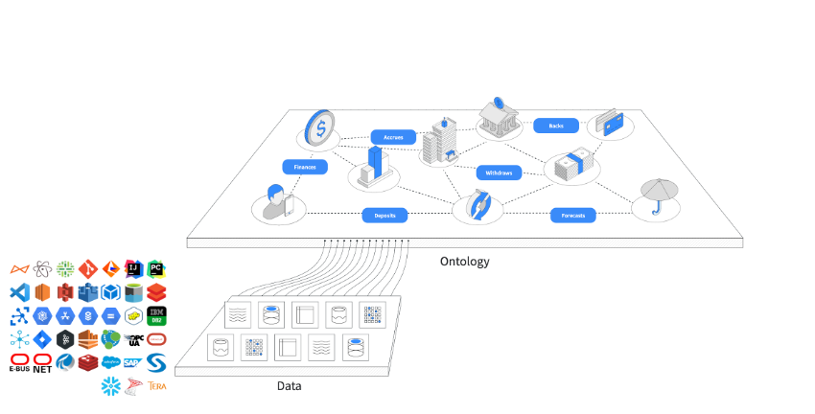

Key Aspects of Data Integration

1. Integrating Company-Wide Data
The Ontology integrates data from diverse sources such as CRM systems like Salesforce, in-house/homegrown centralized systems and many more. The platform enables data federation, which allows the use of existing data platforms and assets without the need for duplication. This approach ensures that data remains consistent and up to date across the organization.

2. Native Connectors and Tools
Foundry provides native connectors for a wide range of data sources, including structured and unstructured data, IoT data, and commercial data sources. It also offers a suite of tools for building Ontology pipelines, accommodating both low-code and pro-code environments. These connectors and tools facilitate quick and seamless integration with systems like SAP, Snowflake, and DataBricks, Amazon S3, among many others.

Recap
To recap : Data Integration = Seamless Connectivity and Federation of Data Sources
Foundry integrates data from various sources within the organization, ensuring seamless connectivity and federation without duplication.
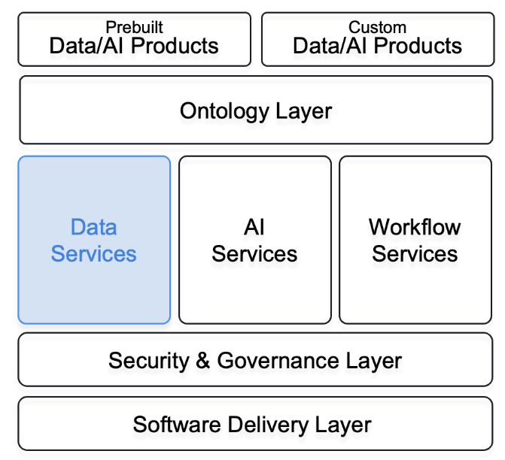

Section 3 - Model Connectivity

Overview
In this section, we will explore how Foundry connects and integrates various models into your data ecosystem. Model connectivity is essential for deriving actionable insights and ensuring that data-driven decisions are based on robust analytical models.

What is Model Connectivity?
Model connectivity in Foundry involves linking analytical models with real-world data and operational workflows. This ensures a seamless collaboration between data scientists, data producers, and end users, enabling the continuous improvement and validation of models.

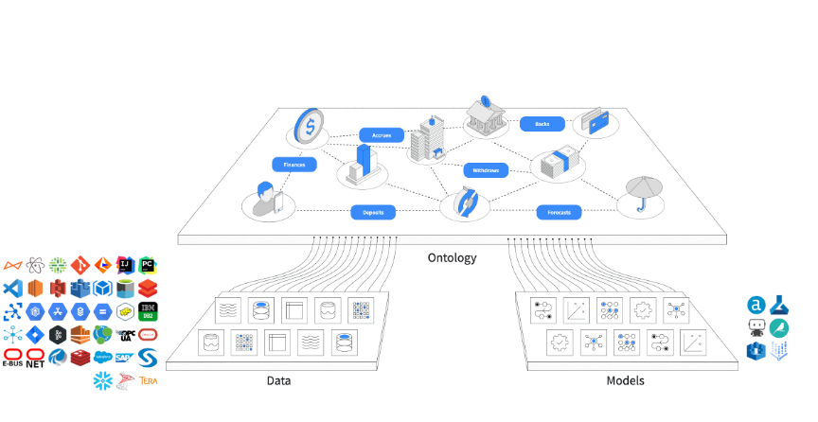

Key Aspects of Model Connectivity

1. Collaborative Model Training and Validation
Foundry offers a suite of modelling applications that allow you to train or validate models on real data in a connected context. This collaboration involves data scientists who build the models, data producers who feed the data, and end users who provide operational feedback. Operational tools are integrated to connect your models directly to workflows, ensuring that insights are immediately actionable.

2. Agnostic Technology Integration
Foundry supports a wide range of models, from home-grown predictive and forecasting models developed by your teams to state-of-the-art Large Language Models (LLMs). Foundry is technology-agnostic, meaning it can integrate with various modelling technologies and platforms.

3. Examples of Model Integrations supported by Foundry and AIP
- In-platform development with open-source tools like TensorFlow, scikit-learn
- Containerized Models pushed into the Foundry Docker registry: Foundry supports containerized models for easy deployment and scalability
- Pro-Code Environment Libraries: Import typical machine learning libraries such as Keras, PyTorch, and Scikit-learn into Foundry’s pro-code environment, enabling advanced model development and integration.
- Externally hosted models integration: with the likes of OpenAI, VertexAI, Sagemaker, etc.

Recap
To recap : Model Connectivity = Seamless Integration of Analytical Models with Data and Workflows
Foundry ensures that your analytical models are seamlessly connected to real data and operational workflows, fostering collaboration and continuous improvement.
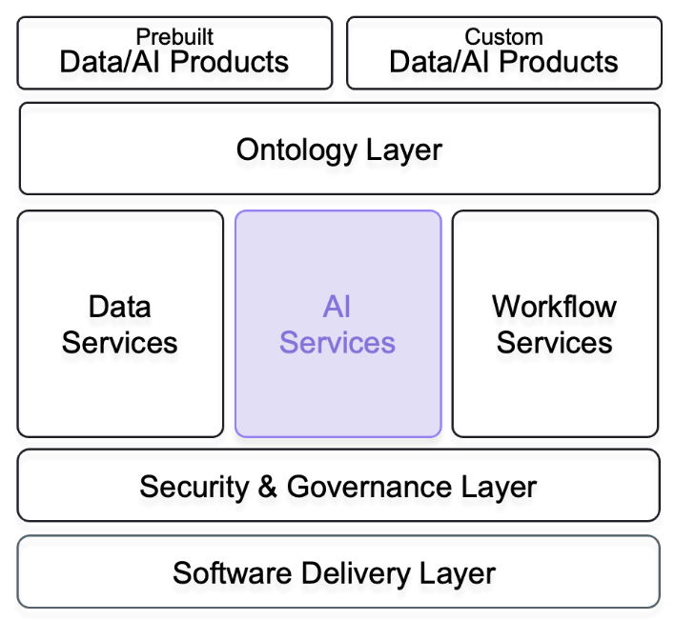

Section 4 - Analytics

Overview
In this section, we will explore the analytics capabilities of Foundry and AIP. This is a crucial component that enables users to derive meaningful insights from data and share these insights across the organization.

What is Analytics in Foundry?
Foundry’s analytics capabilities provide a comprehensive suite of tools that cater to the needs of various users, from data scientists to business analysts. These tools allow for real-time data exploration, dashboard creation, and report generation, all while ensuring robust collaboration and security.

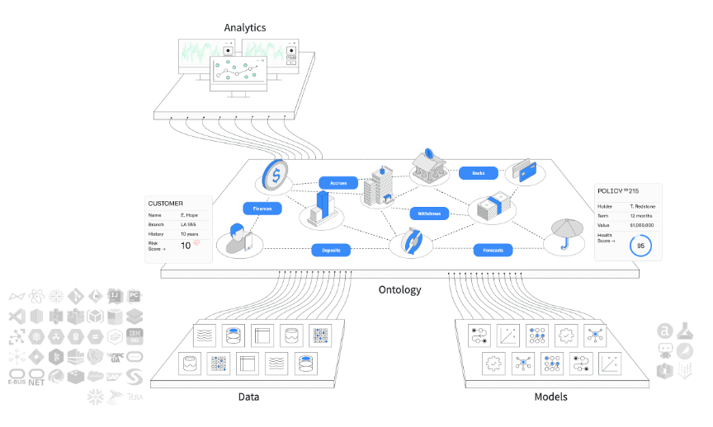

Key Aspects of Analytics

1. A Comprehensive Workbench
Foundry offers a suite of tools that serve as a common workbench for all types of users. Whether you are investigating data, exploring trends, or creating visualizations, Foundry provides the necessary tools to handle data of all scales in real time. This workbench ensures that users can collaborate effectively while maintaining first-class security standards.

2. BI Dashboards and Reports
Foundry makes it easy to build Business Intelligence (BI) dashboards and reports through low-code or no-code applications. These dashboards and reports can be created and customized to meet specific needs and shared with the community of users with just a click. Foundry also respects data access rights, ensuring that sensitive information is only accessible to authorized users.

Recap
To recap: Analytics = Real-Time Exploration, Dashboards, and Secure Collaboration
Foundry’s analytics tools enable users to investigate data, create dashboards, and share insights in real time while ensuring collaboration and data security.
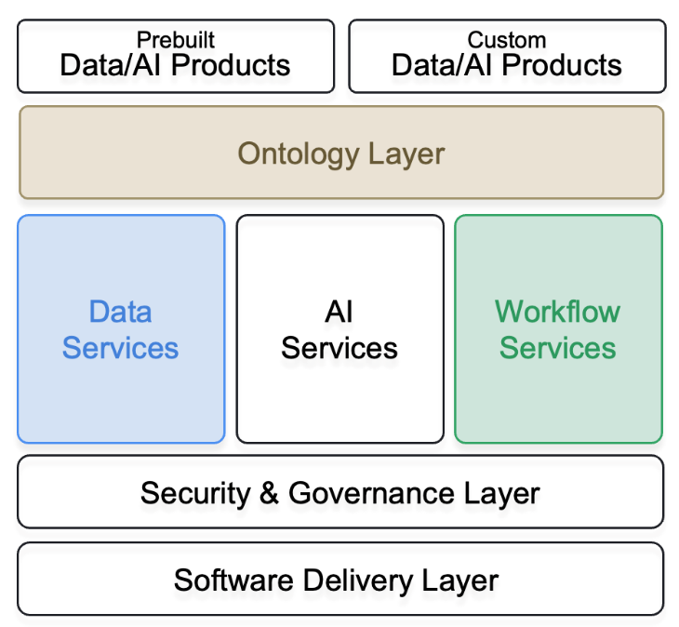

Section 5 - App Building and Workflows

Overview
In this section, we will explore how Foundry and AIP support the creation of operational applications and workflows. App building and workflows are crucial for capturing decisions and ensuring that data-driven insights are actionable and integrated into everyday business processes.

What is application building with Foundry and AIP?
Foundry and AIP contain a number of applications developed to operate natively on top of the Ontology. Together, these object-aware applications deliver a powerful analytical and operational platform that supports a range of use cases and user profiles.

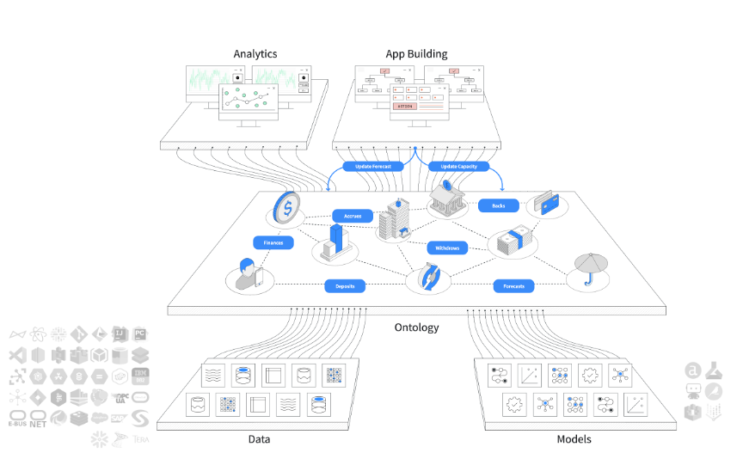

App Building and Workflows with Foundry and AIP
Ontology-Aware Applications
Foundry offers a suite of Ontology-aware applications that provide diverse and scalable methods to build operational applications or workflows. These applications allow users to capture decisions via write-back, ensuring that insights and actions are recorded and integrated into the data ecosystem.

Speed to Value with out-of-the-box Workflows
Users can leverage out-of-the-box workflow templates or reusable workflow components to create workflow applications quickly, often within a matter of days. This accelerated development process ensures that organizations can realize the value of their data and insights swiftly, enhancing efficiency and responsiveness.

Empowering All Skill Levels
Foundry and AIP support no-code, low-code, and pro-code frameworks, empowering users of all skill levels to build and customize applications and workflows. This inclusivity ensures that everyone, from business analysts to seasoned developers, can contribute to and benefit from the platform.

Enhancing Workflows with Foundry Scenario components
Built-In Simulation Capabilities
Foundry includes built-in simulation capabilities that allow users to model “what-if scenarios.” For example, users can simulate the impact of varying parameter rates on key performance indicators (KPIs) or trends. These simulations help in exploring potential outcomes and making informed decisions.

Exploration and Materialization
The “what-if scenarios” can be used purely for exploration or can be materialized by writing the simulation results back into the data once a satisfactory outcome is achieved. This flexibility ensures that users can experiment and validate their strategies before implementation.

Recap
To recap : App Building and Workflows = Rapid Guard-Railed Development
Foundry’s app building and workflow capabilities enable rapid development of operational applications, empowering users of all skill levels to create and customize workflows that enable scenario modeling, capture decisions and integrate insights into business processes.

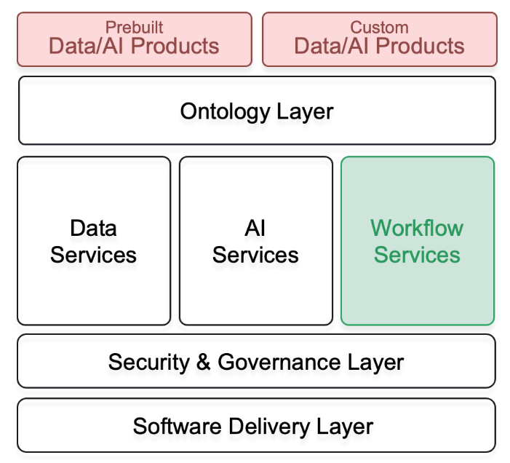

Section 6 - Integrations and Development

Section 6a - Integrations
Overview
In this section, we will explore how Foundry integrates with external systems. Robust integration capabilities are essential for ensuring that data and insights generated within Foundry can be seamlessly utilized across various applications and platforms.

What are integrations with Foundry and AIP ?
While we have discussed ingestion into the platform, it's equally important to consider how data can be read from Foundry into other applications, dashboards, or systems. This capability ensures that the insights and data managed within Foundry are accessible and actionable across the organization.

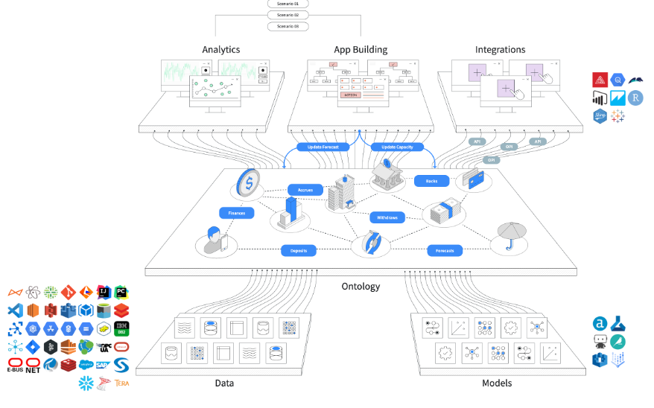

Integrations with Foundry and AIP
API-Driven Development
Foundry supports API-driven development and integration, providing automatic API generation for all elements of the Ontology. This feature simplifies the process of connecting Foundry with other systems and ensures that data flows smoothly between platforms.

Third-Party Authorization Framework
Integration with external systems is made seamless with Foundry’s adherence to third-party authorization frameworks. This ensures that integrations are secure and conform to granular policies, maintaining data integrity and security.

Other Integration Methods
Beyond APIs, Foundry offers various other integration methods, including:
- Streaming and Batch Connectors with Export plugins
- Webhooks: to enable writebacks to external systems using the data connection task
- External Transforms: Allow for data transformations to be performed outside of Foundry, integrating the results back into the system

Section 6b: Front-End and Back-End Development
Overview
Now you’ve seen how Foundry can integrate with external systems, it’s also important to see how Foundry is a toolkit for software development. Foundry allows builders to access the full power of the Ontology directly from their development environment to build on top of Foundry: this is the Ontology Software Development Kit (OSDK). Where Foundry is a backend, developers can also integrate their preferred development environments in Foundry workflows through containers.

Software Development with Foundry
The Ontology Software Development Kit (OSDK) is generated with Developer Console, a portal for creating and managing custom applications using Palantir APIs. This allows developers to create custom frontends, such as React applications, on top of Foundry.
Treating Foundry as a backend leverages the Ontology's robust ability to perform high-scale queries and Foundry write-back alongside granular governance controls to accelerate the process of securely developing applications.
Developers can customize the backend by integrating components of their developer environment directly in Foundry too. Examples include data services like the ability to securely import and host docker containers that contain models or existing data transformation logic.

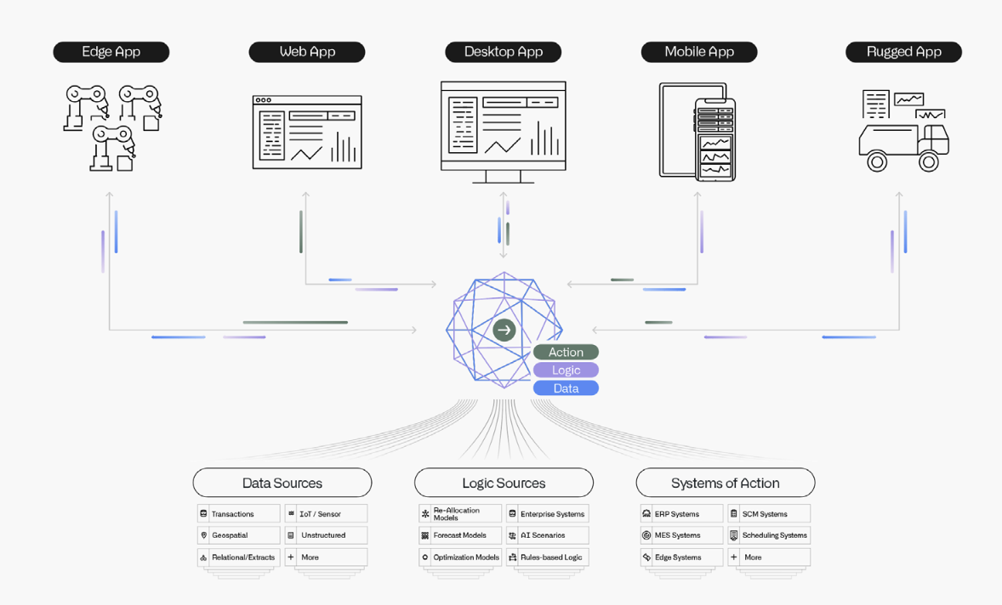

Ontology SDK primary benefits:
- Accelerated development: Faster application development with the OSDK allowing to read and write back to the Ontology with minimal code.
- Strong type-safety: The functions and types generated for the OSDK are based on just the subset of the Ontology relevant to an application. Developers can query and explore their Ontology directly in their editor.
- Centralized maintenance: Central Ontology development and maintenance allows for focus on application building and decreases the typical maintenance burden required to build a data foundation.
- Secure by design: The OSDK uses a token that is scoped only to the ontological entities required for a single application to access, in addition to the user's own permissions to the data.

Technical highlights :
- The Ontology SDK supports NPM (Node Package Manager) package for TypeScript, Pip or Conda for Python, Maven for Java, and OpenAPI spec for any other language

Recap
To recap:
a. Integrations = Seamless Connectivity and Secure Data Flow
Foundry's integration capabilities ensure that data and insights are not confined within the platform but can be seamlessly utilized across various applications and systems, all while maintaining robust security.

b. Development = Accelerated, Secure, and Centralized Application Building
The Ontology SDK (OSDK) provided by Foundry allows developers to quickly and securely build applications that leverage the full power of the Ontology. With strong type-safety, centralized maintenance, and robust governance controls, the OSDK streamlines the development process.
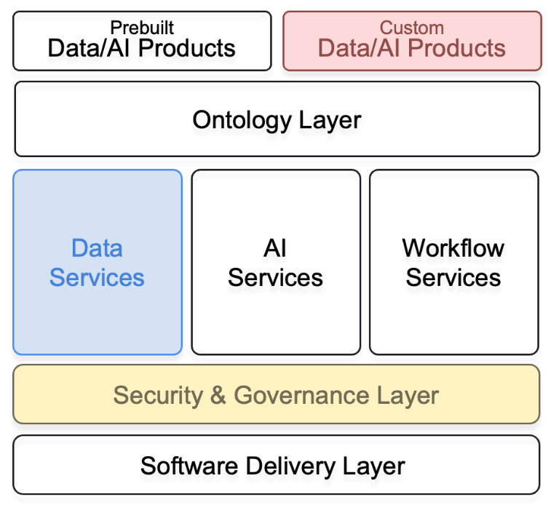

Section 7 - AIP
Overview
In this section, we will explore the intrinsic connection between AIP and the evolution of the Foundry platform. With the generalization of need for and access to generative AI tools in data-driven environments, Foundry and AIP naturally complement each other to build the operational software of tomorrow.

What is AIP?
AIP connects generative AI to operations. It is a suite of modules built into Foundry with specific configurable governance principles that enable users or administrators to select their preferred LLM, control its usage, while fully harnessing its capabilities.

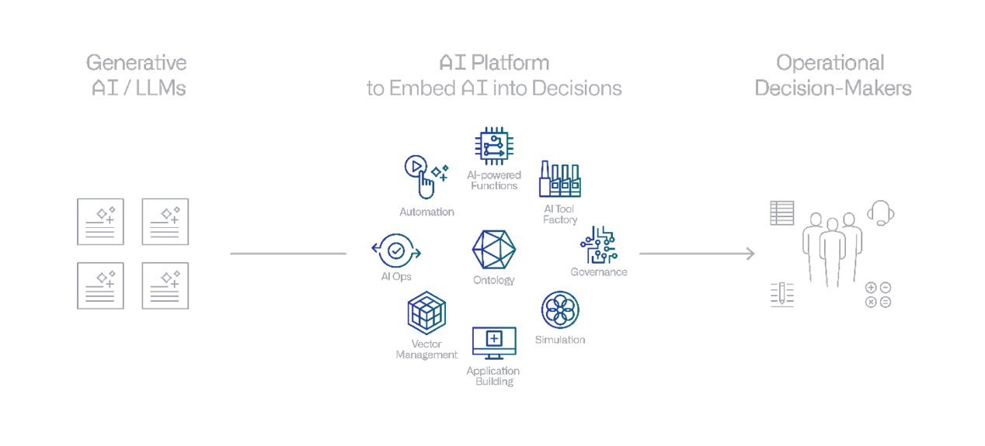

Diving into the components of AIP
A logical extension of Foundry
- Product developments to integrate AI capabilities with existing applications (eg. Automate, Workshop widgets, pipeline builder transforms etc) to allow users to leverage LLMs directly in their workflows without worrying about the development specifics
- AIP developer capabilities allow developers to build their own LLM-backed workflows or applications in Foundry
- Supported models list is ever growing as the platform is tech-agnostic : LLAMA, GPT, Claude, and more!
- The same best-in-class security model and permissions framework as that propagating across the entire Foundry platform for the organization
- Additional capabilities in the robust set of tools to manage the platform to govern model availability and accessibility, and monitor resource consumption

Operationalization of LLMs
- AIP Logic: a no-code development environment for building, testing, and releasing functions powered by LLMs. Using Logic’s intuitive interface, application builders can engineer prompts, test, evaluate and monitor, set up automation, and more, while leveraging the Ontology.
- AIP Logic Evaluations: a testing framework designed to enhance and track AIP Logic function quality over time by improving prompt engineering, deciding between using various models

Helpers for builders
- AIP Assist: an LLM-powered support tool designed to help users navigate, understand, and generate value with the Palantir platform
- AIP features in platform applications: in platform LLM powered assistance : Native LLM-backed features designed to help end users perform regular workflows in Foundry. These are highly-specific features that leverage knowledge of the Foundry platform to accelerate a user's day-to-day operations.

Recap
To recap : AIP = Foundry + GenAI
AIP seamlessly integrates generative AI capabilities into Foundry, providing powerful tools and features that enhance operational workflows and data-driven decision-making.

